Student and Alumni Instructions
ACCESSING COYOTE CAREERS
Login Screen. Go to www.usd.edu/coyotecareers and select the Student Login Link (for current USD students) or the Alumni login link (for alumni, faculty, or staff accounts). Current USD students will be prompted to log into their MyUSD portal. Alumni, faculty, and staff members will need to log in using the credentials they set up when they registered for their account. Upon first use, click Sign Up.
*Troubleshooting-if a student is being asked to sign up for an account, they need to log out of their myusdportal, delete their website cache and try again.
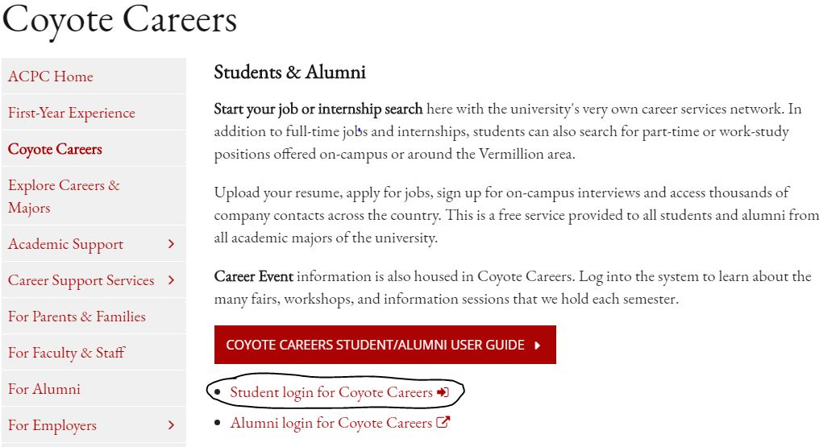
Homepage of Coyote Careers.
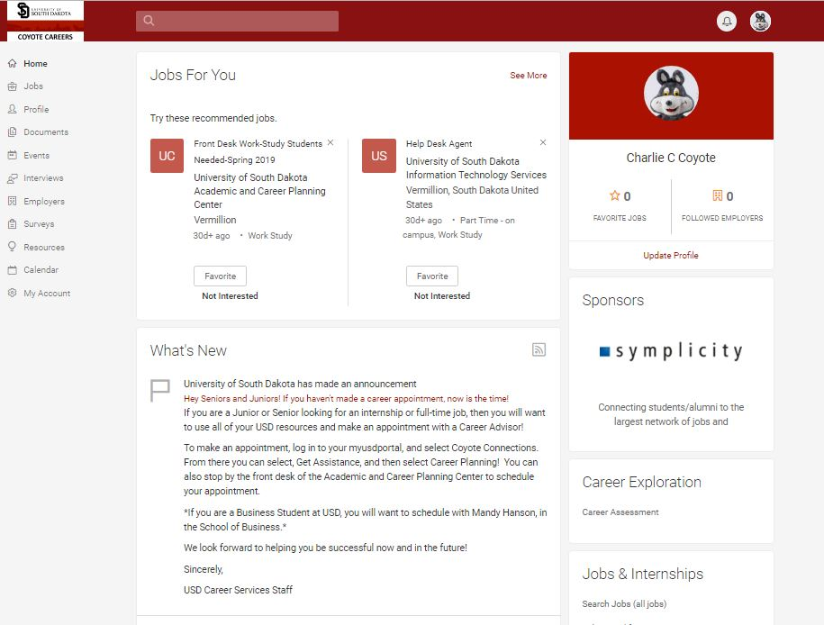
SEARCHING FOR JOBS
Searching for Jobs in Coyote Careers. Select the Jobs tab and then select Search under the dropdown menu.
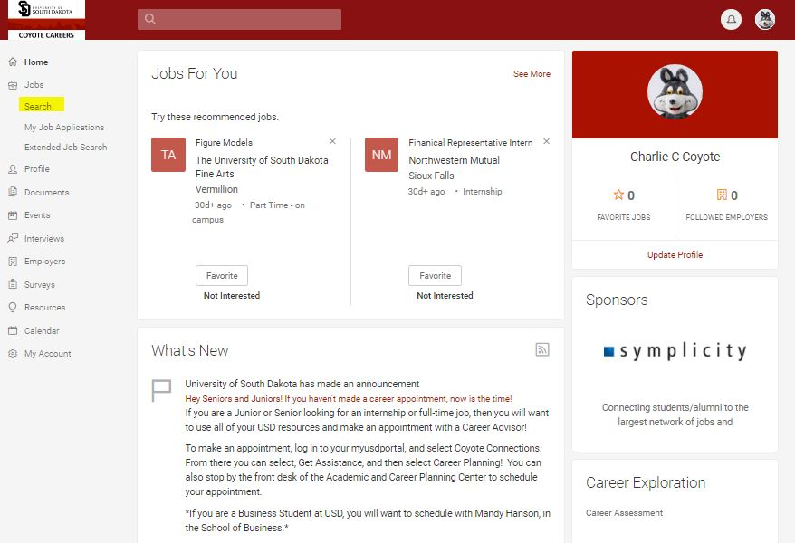
Job Search Page-You can search by keyword or location, or use the various filters to search by position type, industry, job function, and more. The Job Search page will also suggest jobs and careers based on your profile information.
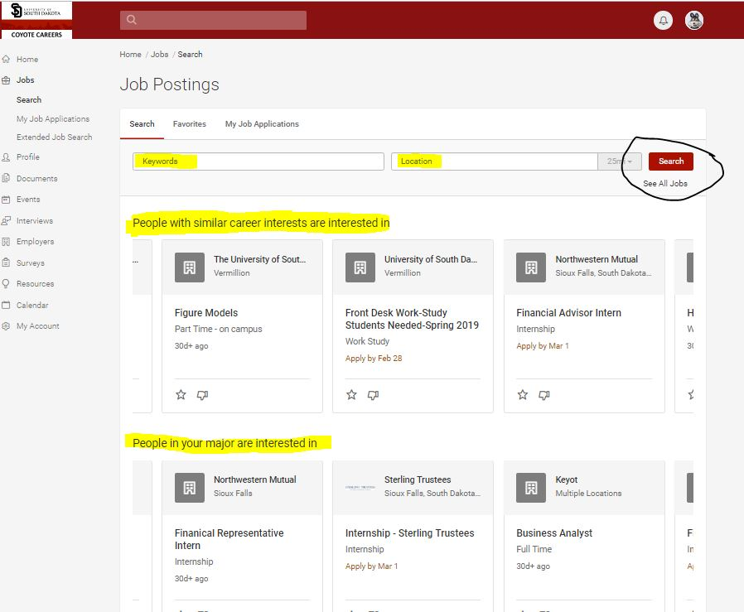
Job Search Advanced- From “More Filters”, you can search by major, work authorization, date posted, required travel, and on-campus interview schedules.
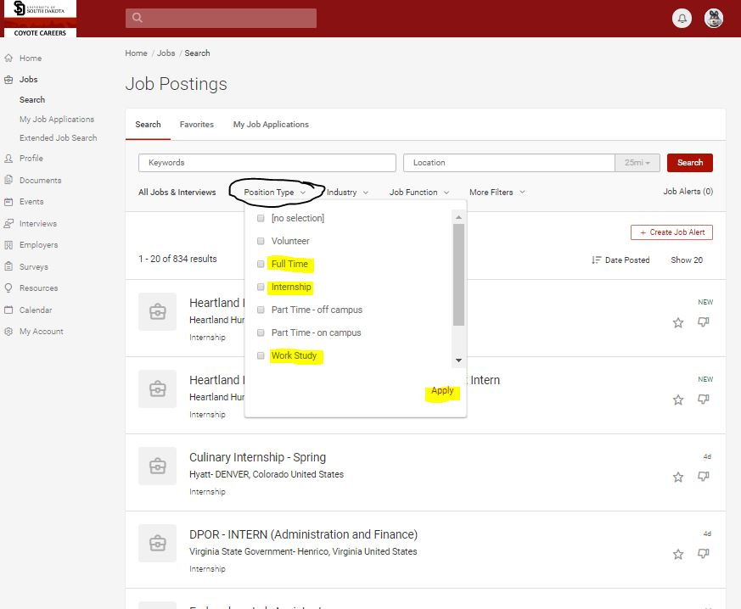
Results of Advanced Search.
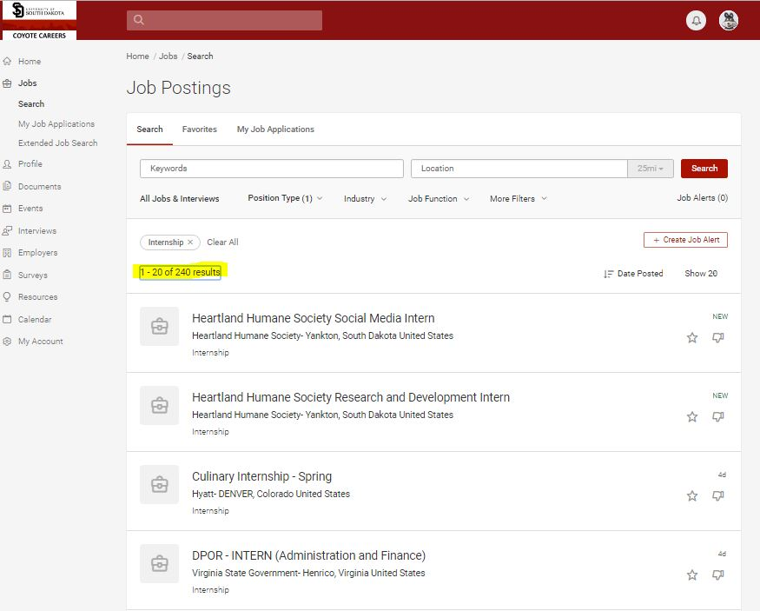
Sample Job Description. Click the “Apply” button to view the application instructions.
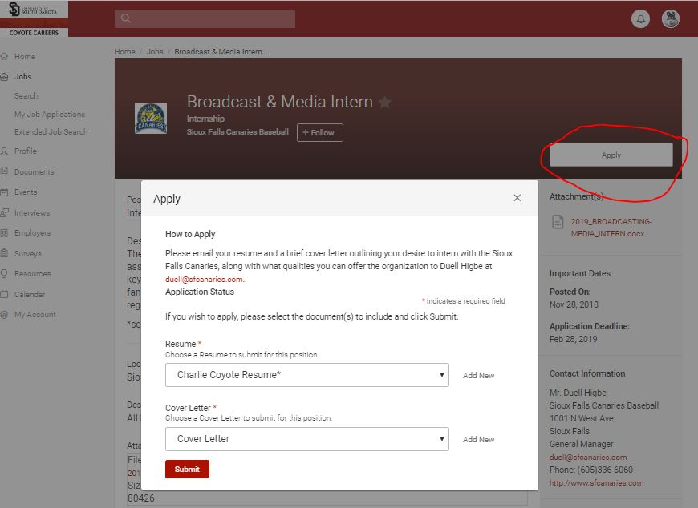
PROFILE SET UP
Student Profile Screen. Click on the profile button in the menu bar on the left-hand side. This is where users can have an “online” resume or profile that can be shared with employers and references. A professional photo, objective or summary, education, experience, and special projects an skills can all be added in the profile section.
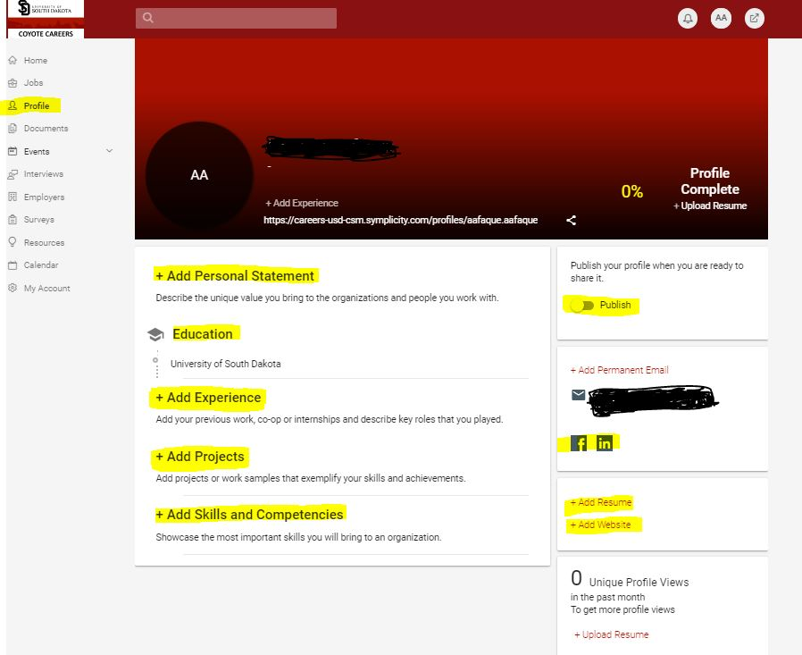
Completed Student Profile Example. Here is a sample of a completed profile. Once a user feels comfortable with their profile, they can select the Publish button, which gives them a link to share with employers and references. This link is available by clicking on “Share it!”
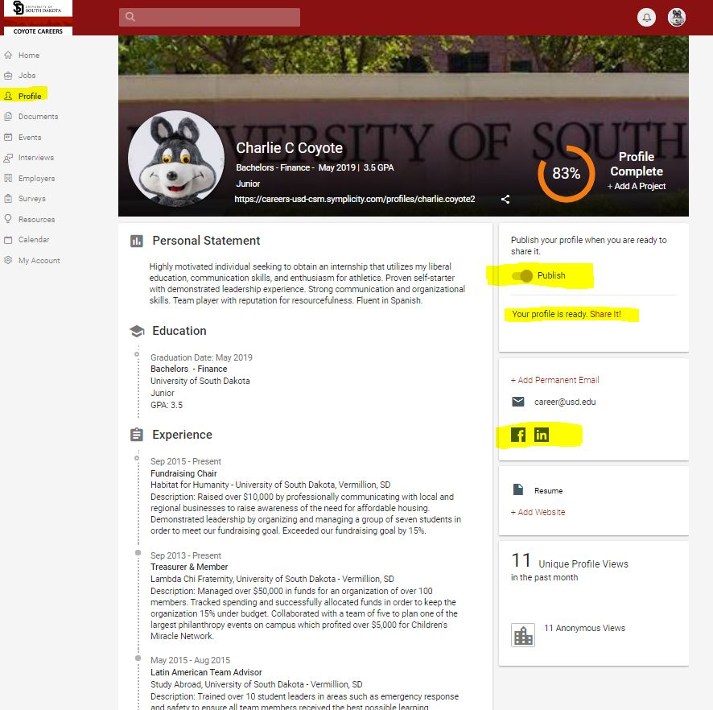
UPLOADING DOCUMENTS
Document Home Page. Users can upload their résumés, cover letters, and writing samples to Coyote Careers under the Documents tab on the left-hand side dropdown menu. Select Documents, My Documents and then Add New. Some documents may require approval by career center staff before they are published in the system.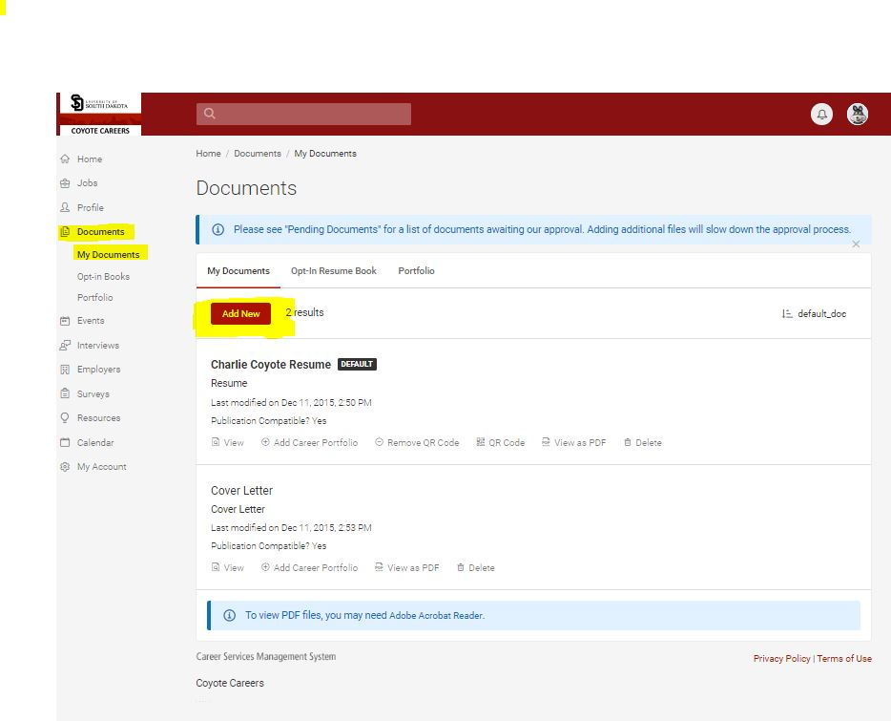
Document Upload Screen 2. Users will name their documents (i.e. Healthcare Resume), select the document type, and then select “Choose file” to upload their document. Users can also select the “Promote Me to Employers” button which allows their résumé and profile to be searchable to employers within Coyote Careers and the extended Symplicity Careers database.
